Wrenched Rhyme

🔹 What is Wrenched Rhyme
# Source: Chatgpt (GPT-4-turbo) at [8/2/2025]
⚠️ Wrenched rhyme is a poetic technique, not a linguistic type of homograph.
However, homographs can sometimes be used in wrenched rhyme—if their pronunciation is distorted to force a rhyme.

✅ Definition of Wrenched Rhyme
# Source: Chatgpt (GPT-4-turbo) at [8/2/2025]
Wrenched rhyme occurs when the natural stress or pronunciation of a word is unnaturally forced or altered to make it rhyme with another line.
This involves twisting grammar, stress, or meaning—sometimes awkwardly—to fit rhyme or meter.

🧠 Key Features of Wrenched Rhyme
# Source: Chatgpt (GPT-4-turbo) at [8/2/2025]
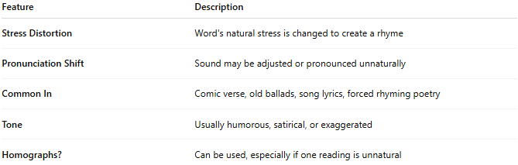
Feature | Description
Stress Distortion | Word's natural stress is changed to create a rhyme
Pronunciation Shift | Sound may be adjusted or pronounced unnaturally
Common In | Comic verse, old ballads, song lyrics, forced rhyming poetry
Tone | Usually humorous, satirical, or exaggerated
Homographs? | Can be used, especially if one reading is unnatural

📝 Example of Wrenched Rhyme
# Source: Chatgpt (GPT-4-turbo) at [8/2/2025]
He fought with courage, bold and valiant,
But fled the field to save his client.
- Natural pronunciation: val-i-ant (/ˈvæl.i.ənt/) vs client (/ˈklaɪ.ənt/)
- The rhyme is forced, requiring unnatural stress—this is wrenched rhyme.

🧪 Using Homographs in Wrenched Rhyme
# Source: Chatgpt (GPT-4-turbo) at [8/2/2025]
Homographs may be used in wrenched rhyme if:
- The intended meaning is clear.
- The unnatural reading forces rhyme.

✅ Example with "lead" (/lɛd/ or /liːd/):
He drew the curtain, soft and red
And in his hand, a pipe of lead.
If pronounced /liːd/ (incorrect for the metal), this would force a rhyme—thus a wrenched rhyme using a homograph.

✅ Example with "tear":
Her eyes began to overflow
She dropped a heartfelt silent tear
And whispered softly in his ear.
No wrenching here — this is a perfect rhyme.
But if you had:
She didn’t mean to cause a tear
But still she pulled the chandelier.
You would wrench the meaning and rhythm to make “tear” (/tɛr/) rhyme with “chandelier,” which ends in /ɪr/ — that's wrenched.

✅ Summary
# Source: Chatgpt (GPT-4-turbo) at [8/2/2025]
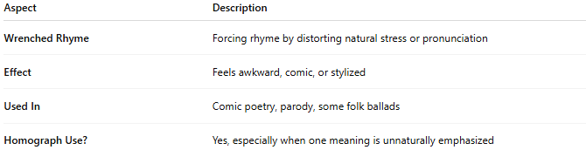
Aspect | Description
Wrenched Rhyme | Forcing rhyme by distorting natural stress or pronunciation
Effect | Feels awkward, comic, or stylized
Used In | Comic poetry, parody, some folk ballads
Homograph Use? | Yes, especially when one meaning is unnaturally emphasized

